Exercise 10

Build a chatbot for the Indian Penal Code. We'll start by downloading the official Indian Penal Code document, and then we'll create a chatbot that can interact with it. Users will be able to ask questions about the Indian Penal Code and have a conversation with it.

# Install libraries
!pip install fastapi uvicorn nest_asyncio gradio

# Imports
from fastapi import FastAPI, Body
import nest_asyncio, uvicorn, threading, gradio as gr, requests

# FastAPI app
app, codes = FastAPI(), []

@app.get("/")
def home(): return {"info": "Indian Penal Code", "queries": ["0: Theft", "1: Bribery", "2: Total sections"]}

@app.post("/ipc")
def add(fapi: dict = Body(...)): codes.append(fapi); return {"Details": f"{fapi['IPC']}, {fapi['case']}, {fapi['punishment']}"}

@app.get("/{i}")
def get(i: int): return codes[i] if 0 <= i < len(codes) else {"error": "Invalid index"}

# Run server
nest_asyncio.apply()
threading.Thread(target=lambda: uvicorn.run(app, host="0.0.0.0", port=8000)).start()

# Gradio app
demo = gr.Blocks()

with demo:
gr.Markdown("# IPC Chatbot")

gr.Button("Show Info").click(lambda: requests.get("http://127.0.0.1:8000/").json(), outputs=gr.Textbox())
with gr.Row():
i, c, p = gr.Textbox(placeholder="IPC"), gr.Textbox(placeholder="Case"), gr.Textbox(placeholder="Punishment")
gr.Button("Add IPC").click(lambda ipc, case, pun: requests.post("http://127.0.0.1:8000/ipc", json={"IPC": ipc, "case": case, "punishment": pun}).json(), inputs=[i, c, p], outputs=gr.Textbox())
idx = gr.Number(label="Index")
gr.Button("Get IPC").click(lambda index: requests.get(f"http://127.0.0.1:8000/{int(index)}").json(), inputs=idx, outputs=gr.Textbox())

demo.launch(share=True)
Output:

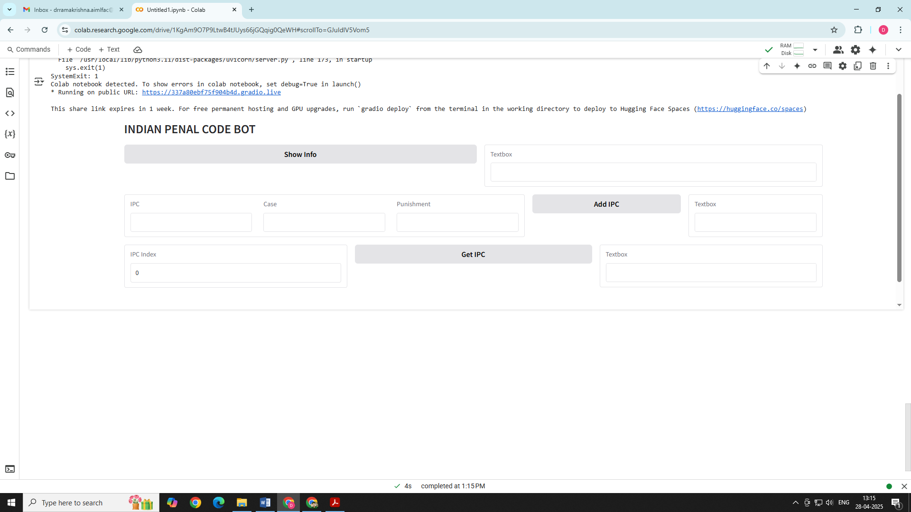

In the above chatbot, give following inputs as follows:
First click: Show Info button, It will display, {"info": "Indian Penal Code" }
In Add IPC Section, Kindly enter following in 3 Textboxes:
In IPC Textbox, Enter 378
In Case Textbox, Enter Theft
In Punishment Textbox, Enter Up to 3 years imprisonment or fine
Now Click ADD IPC Button, it will display
"Details": "Section 378, Theft, Up to 3 years imprisonment or fine"
Now, in Below INDEX Textbox enter 0 and click GET IPC
In the below textbox, it will display as follows:
"IPC": "Section 378”, "case": "Theft", "punishment": "Up to 3 years imprisonment or fine"

Similarly repeat the process, by entering multiple values and keep clicking GET IPC by entering 1, 2,3 in Index Textbox for every IPC Case

